DASH Azure Kubernetes Service

Prerequisites

- Azure CLI: Install and configure the Azure CLI on your local machine to run the commands below.
  - Install Azure CLI

- Kubernetes CLI tool to interact with your cluster.
  - Install Kubernetes CLI

Input Guide
This outlines the input parameters available during Azure Kubernetes Service (AKS) provisioning via the DASH Portal.Each row describes a specific parameter, including its meaning, possible values, recommended values, and any valid combinations.

Input Parameter | Description | Values Provided | Value Guidance | Valid Combinations
cluster_name | Name of the AKS cluster. | User-defined string  e,g. akscluster | Must be unique within the subscription. | N/A
region | Azure region where the AKS cluster will be deployed. | East US, Central US, West Europe, Central India, UK South, Canada Central, East Asia, etc. | Choose the one closest to your workload for better latency. | N/A
kubernetes_version | Kubernetes version for the cluster. | Versions available:  1.31.7,  1.31.6,  1.31.5 | Recommended to use the Latest version unless a specific version is required. | Must be a supported AKS version.
node_count | Number of nodes in the AKS cluster. | Numeric value  1,2,3,4,5,6 | Used for fixed-size node pools. | Mutually exclusive with autoscaling settings.
minimum_nodes | Minimum number of nodes when autoscaling is enabled. | Numeric value  0,1,2,3 | Recommended starting value: 1 or 2. | Must be ≤ maximum_nodes.
maximum_nodes | The maximum number of nodes when autoscaling is enabled. | Numeric value  1,2,3,4,5,6 | Recommended: depends on workload scaling. | Must be ≥ minimum_nodes.
vm_size | Size of the Azure VM for worker nodes. | Examples:  Standard_DS1_v2  Standard_DS2_v3Standard_D2as_v4,Standard_B2s | Choose based on workload performance needs. | N/A
disk_size_gb | OS disk size in GB for AKS nodes. | Disk size available  30,40,50,60..100 | Must be > 30 GB | N/A
owner | The team or individual responsible for provisioning, managing, and maintaining the  resource. | Specify the team name or individual responsible for maintaining the cluster. | Provide correct team/individual name. | N/A
application | Associated service or application name for the resource. | Enter the associated service name linked to the cluster. | Provide a service name linked to the cluster. | N/A
project | Project or initiative name linked to the resource. | Indicate the project or initiative name related to the resource. | Provide the project name related to the cluster. | N/A
deployment | The target environment (e.g., development, testing, prod) where the cluster will be provisioned. | Define the deployment environment name (e.g., dev, test, prod) | Choose the environment where the cluster has to be deployed. | N/A
Services expire after 30 days. Create this service now, or schedule for a later date? | Cluster will be deleted 30 days after creation, or it can be scheduled to be created at a later date. | Create Now (or)  Schedule for Later | Choose based on cluster requirements. | N/A

Sample Input Selection:
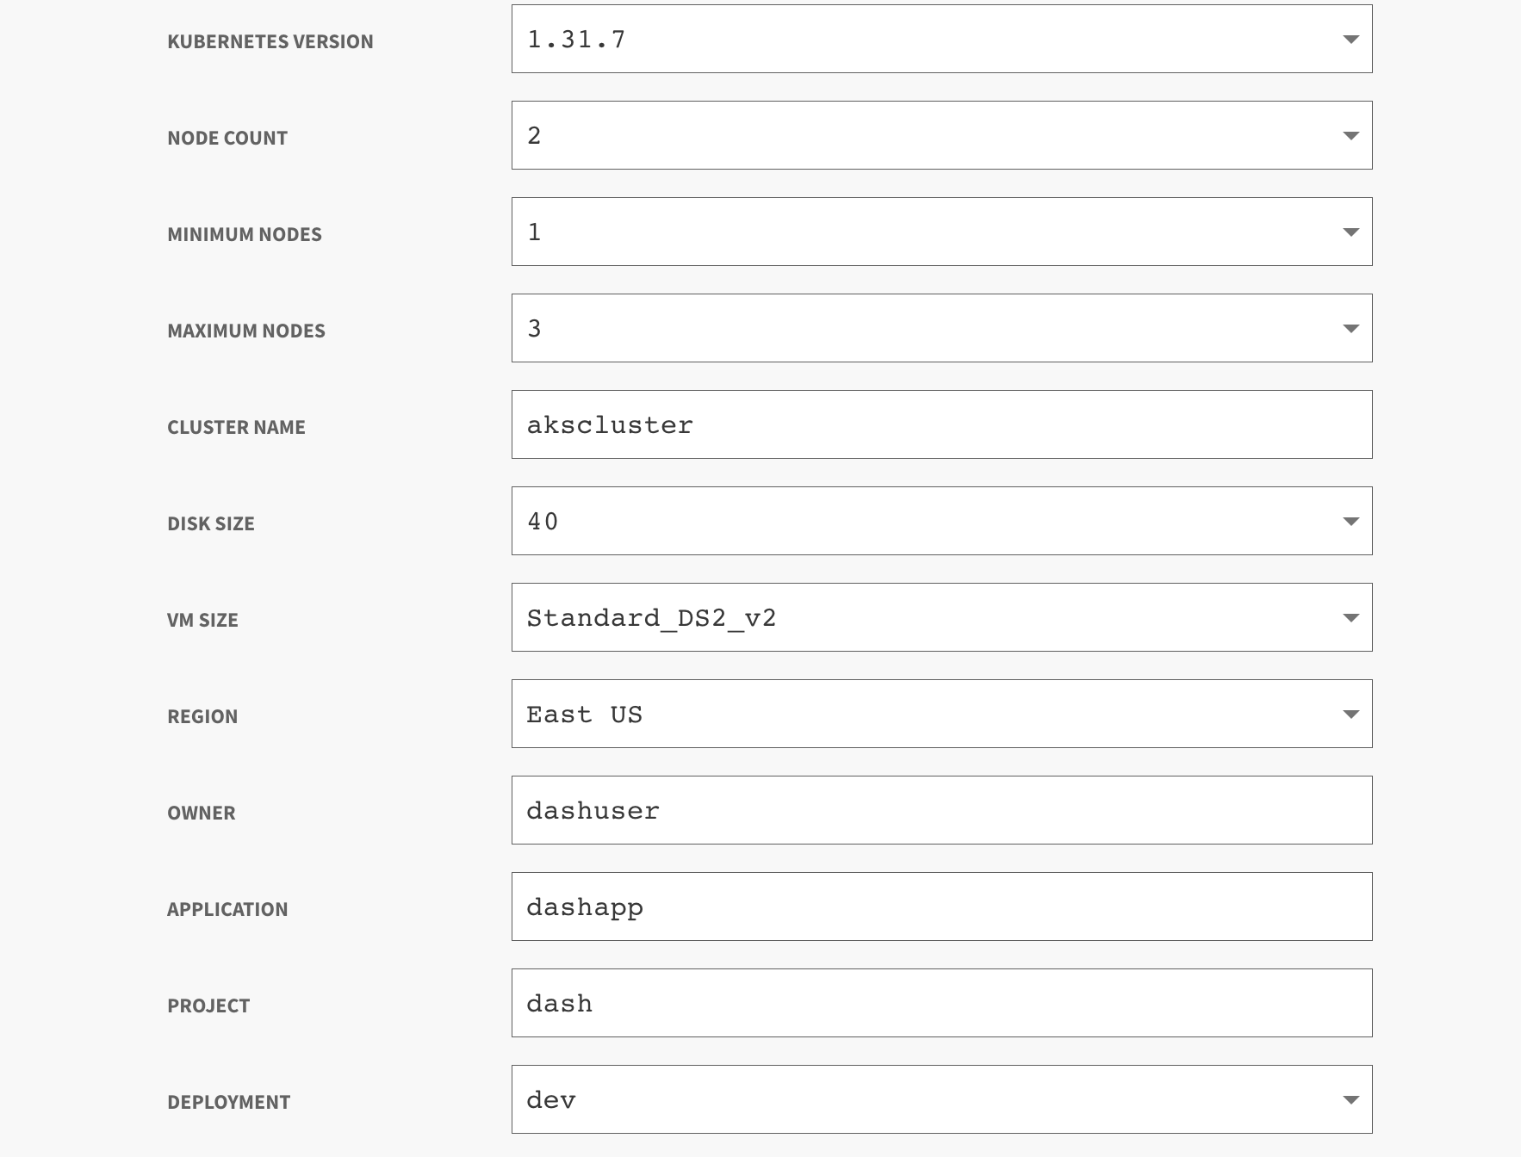


Output Guide:
After provisioning the Azure Kubernetes Service (AKS) cluster, the following output values are available.These outputs are essential for accessing the Kubernetes API server, configuring authentication, and managing workloads within the cluster.
Output | Description | Example Value
resource_group_name | Name of the resource group containing the AKS cluster. | dash-aks-rg
aks_cluster_name | Name of the provisioned AKS cluster. | dash-aks-cluster1
kube_config | Raw Kubernetes config file used to authenticate with the cluster. | Sensitive value (YAML content)
cluster_endpoint | API server endpoint (control plane URL) for the cluster. | https://dash-aks-cluster1-12345.hcp.eastus.azmk8s.io:443
cluster_credentials | Command to fetch cluster admin credentials. | az aks get-credentials --resource-group dash-aks-rg --name dash-aks-cluster1
cluster_access | Step-by-step instructions for logging in and accessing the cluster. | Multi-line Azure CLI steps
Delete_resource_group | Command to delete the AKS resource group when no longer needed. | az group delete --name dash-aks-rg --yes --no-wait

What You Can Do with These Outputs
This document outlines the output values generated after Azure Kubernetes Service (AKS) provisioning through the DASH Portal.These values can be used to securely access, manage, and interact with your Kubernetes cluster.

Access the AKS Cluster
1. Copy the kubeconfig output into a file
Copy the value shown under kube_config output.
Save it into a new file called kubeconfig-aks.yaml.(e.g)
2. Example:
Linux/macOS:
vi kubeconfig-aks.yaml
# paste the content, then save and exit
Windows (PowerShell):
notepad.exe kubeconfig-aks.yaml
# paste the content, then save
3. Set the kubeconfig environment variable
Linux/macOS:
export KUBECONFIG=$PWD/kubeconfig-aks.yaml
kubectl get nodes
Windows PowerShell:
$env:KUBECONFIG = "$PWD\kubeconfig-aks.yaml"
kubectl get nodes
Windows CMD:
set KUBECONFIG=%cd%\kubeconfig-aks.yaml
kubectl get nodes

4. (Optional) Merge with existing kubeconfig
If you already have other cluster configs:
Linux/macOS:
export KUBECONFIG=$PWD/kubeconfig-aks.yaml:~/.kube/config
kubectl config view --merge --flatten > ~/.kube/config
Windows PowerShell:
$env:KUBECONFIG = "$PWD\kubeconfig-aks.yaml;$HOME\.kube\config"
kubectl config view --merge --flatten | Out-File -Encoding utf8 $HOME\.kube\config
Switch between contexts if multiple clusters exist
kubectl config get-contexts
kubectl config use-context <context-name>

Recommendation: Instruct users to always copy the kube_config output into a dedicated file before setting KUBECONFIG.
Delete the Cluster
Once your work is complete, use the Delete_resource_group output to clean up all resources:
az group delete --name <resource_group_name> --yes --no-wait

